NAME: RAJA RAYYAN AMEER
REG. NO.: 23-CP-25
SECTION: ALPHA
SUBJECT: ML&AI
DEPARTMENT: COMPUTER ENGINEERING
TEACHER: SIR SHAHID
LAB 6:
Task:
- Predict Probability of Buying Insurance:
Use model.predict_proba(X_test) to get the probability estimates for each test instance instead of just the class labels.
- Modify Training Data Split Ratio:
Change the train-test split ratio from 80-20 to 70-30 or 60-40 and observe how it affects model performance.
- Evaluate Model Performance Using a Confusion Matrix:
Use sklearn.metrics.confusion_matrix to generate and analyze the confusion matrix for the test predictions.
- Visualize the Sigmoid Function:
Plot the sigmoid function over a range of values using Matplotlib to see how it maps inputs to probabilities.
- Test Model on New Data:
Manually input a new age value, pass it through the trained model using.predict(), and determine whether the person is likely to buy insurance.
Program:
# Step 1: Import Libraries
import math
import pandas as pd
import numpy as np
import matplotlib.pyplot as plt
from sklearn.model_selection import train_test_split
from sklearn.linear_model import LogisticRegression
from sklearn.metrics import confusion_matrix

# Step 2: Load Dataset
df = pd.read_csv("Lab 6 Insurance Dataset.csv")

# Step 3: Visualize Data
plt.scatter(df.age, df.bought_insurance, marker = '+', color = 'red')
plt.xlabel("Age")
plt.ylabel("Bought Insurance")
plt.title("Age vs Insurance Purchase")
plt.show()

# Step 4: Train and Evaluate Models for Multiple Split Ratios
split_ratios = [0.8, 0.7, 0.6]
labels = ['80-20', '70-30', '60-40']
accuracies = []

print("\nModel Evaluation for Different Split Ratios")
for ratio, label in zip(split_ratios, labels):
print(f"SPLIT RATIO: {label}")

# Split Data
X_train, X_test, y_train, y_test = train_test_split(
df[['age']], df.bought_insurance, train_size = ratio, random_state = 42
)

# Train Model
model = LogisticRegression()
model.fit(X_train, y_train)

# Predictions
y_predicted = model.predict(X_test)
y_prob = model.predict_proba(X_test)

print("\nPredicted Classes:")
print(y_predicted)

print("\nPredicted Probabilities [P(No), P(Yes)]:")
print(y_prob)

# Model Accuracy
accuracy = model.score(X_test, y_test)
accuracies.append(accuracy)
print(f"\nModel Accuracy ({label}): {accuracy:.4f}")

# Confusion Matrix
cm = confusion_matrix(y_test, y_predicted)
print("\nConfusion Matrix:")
print(cm)

# Bar graph: accuracy vs split ratio
plt.bar(labels, accuracies, color = ['steelblue', 'darkorange', 'seagreen'])
plt.xlabel("Train-Test Split Ratio")
plt.ylabel("Accuracy")
plt.title("Model Accuracy for Different Split Ratios")
plt.ylim(0, 1)
for i, acc in enumerate(accuracies):
plt.text(i, acc + 0.02, f"{acc:.2f}", ha = 'center', fontweight = 'bold')
plt.show()

# Step 5: Sigmoid Function Visualization
def sigmoid(x):
return 1 / (1 + np.exp(-x))

x = np.linspace(-10, 10, 100)
y = sigmoid(x)

plt.plot(x, y)
plt.xlabel("z")
plt.ylabel("Sigmoid(z)")
plt.title("Sigmoid Function")
plt.grid()
plt.show()

# Step 6: Test on New Data
new_age = [[35]]

prediction = model.predict(new_age)
probability = model.predict_proba(new_age)

print("\nNew Input (Age = 35)")
print("Prediction:", prediction)
print("Probability [P(No), P(Yes)]:", probability)

# Step 7: Manual Prediction Function
def manual_sigmoid(x):
return 1 / (1 + math.exp(-x))

def prediction_function(age):
z = 0.042 * age - 1.53
return manual_sigmoid(z)

print("\nManual Predictions:")
print("Age 35:", prediction_function(35))
print("Age 43:", prediction_function(43))
Output:
Model Evaluation for Different Split Ratios
SPLIT RATIO: 80-20

Predicted Classes:
[1 1 1 0 1 1 0 1 0 1 1 1 0 0 1 0 0 0 1 1]

Predicted Probabilities [P(No), P(Yes)]:
[[0.00000000e+00 1.00000000e+00]
[4.44089210e-16 1.00000000e+00]
[1.20277899e-09 9.99999999e-01]
[9.99876535e-01 1.23464732e-04]
[7.12154771e-04 9.99287845e-01]
[2.07692597e-01 7.92307403e-01]
[1.00000000e+00 2.48122407e-12]
[1.70530257e-13 1.00000000e+00]
[9.99998530e-01 1.47015547e-06]
[7.46736006e-13 1.00000000e+00]
[3.11129605e-03 9.96888704e-01]
[8.88178420e-15 1.00000000e+00]
[9.99876535e-01 1.23464732e-04]
[9.99459529e-01 5.40471295e-04]
[3.88578059e-14 1.00000000e+00]
[9.99999982e-01 1.75037562e-08]
[9.99459529e-01 5.40471295e-04]
[9.99999982e-01 1.75037562e-08]
[6.27138341e-11 1.00000000e+00]
[8.48491428e-06 9.99991515e-01]]

Model Accuracy (80-20): 1.0000

Confusion Matrix:
[[ 8 0]
[ 0 12]]
SPLIT RATIO: 70-30

Predicted Classes:
[1 1 1 0 1 1 0 1 0 1 1 1 0 0 1 0 0 0 1 1 1 1 1 0 1 0 0 0 0 1]

Predicted Probabilities [P(No), P(Yes)]:
[[6.66133815e-16 1.00000000e+00]
[2.44249065e-15 1.00000000e+00]
[3.12015325e-09 9.99999997e-01]
[9.99811129e-01 1.88871166e-04]
[9.93238895e-04 9.99006761e-01]
[2.17275006e-01 7.82724994e-01]
[1.00000000e+00 8.67964300e-12]
[6.68798350e-13 1.00000000e+00]
[9.99997234e-01 2.76573163e-06]
[2.73381318e-12 1.00000000e+00]
[4.04764739e-03 9.95952353e-01]
[3.99680289e-14 1.00000000e+00]
[9.99811129e-01 1.88871166e-04]
[9.99228402e-01 7.71598341e-04]
[1.63646874e-13 1.00000000e+00]
[9.99999960e-01 4.04925159e-08]
[9.99228402e-01 7.71598341e-04]
[9.99999960e-01 4.04925159e-08]
[1.86731741e-10 1.00000000e+00]
[1.45560155e-05 9.99985444e-01]
[0.00000000e+00 1.00000000e+00]
[9.93238895e-04 9.99006761e-01]
[6.35898583e-02 9.36410142e-01]
[9.49899656e-01 5.01003436e-02]
[2.44249065e-15 1.00000000e+00]
[1.00000000e+00 3.54797607e-11]
[9.99999834e-01 1.65521162e-07]
[9.99999990e-01 9.90594599e-09]
[9.99997234e-01 2.76573163e-06]
[1.86731741e-10 1.00000000e+00]]

Model Accuracy (70-30): 1.0000

Confusion Matrix:
[[13 0]
[ 0 17]]
SPLIT RATIO: 60-40

Predicted Classes:
[1 1 1 0 1 1 0 1 0 1 1 1 0 0 1 0 0 0 1 1 1 1 1 0 1 0 0 0 0 1 1 1 1 1 1 1 1
0 1 1]

Predicted Probabilities [P(No), P(Yes)]:
[[1.13242749e-14 1.00000000e+00]
[4.17443857e-14 1.00000000e+00]
[1.85794790e-08 9.99999981e-01]
[9.99729195e-01 2.70805027e-04]
[2.25030608e-03 9.97749694e-01]
[2.90815547e-01 7.09184453e-01]
[1.00000000e+00 4.50670445e-11]
[7.57838237e-12 1.00000000e+00]
[9.99994529e-01 5.47070319e-06]
[2.78281842e-11 1.00000000e+00]
[8.21386629e-03 9.91786134e-01]
[5.61994895e-13 1.00000000e+00]
[9.99729195e-01 2.70805027e-04]
[9.99006307e-01 9.93692889e-04]
[2.06390460e-12 1.00000000e+00]
[9.99999890e-01 1.10488395e-07]
[9.99006307e-01 9.93692889e-04]
[9.99999890e-01 1.10488395e-07]
[1.37788936e-09 9.99999999e-01]
[4.55482182e-05 9.99954452e-01]
[8.88178420e-16 1.00000000e+00]
[2.25030608e-03 9.97749694e-01]
[1.00455030e-01 8.99544970e-01]
[9.53061038e-01 4.69389623e-02]
[4.17443857e-14 1.00000000e+00]
[1.00000000e+00 1.65488829e-10]
[9.99999594e-01 4.05719743e-07]
[9.99999970e-01 3.00889542e-08]
[9.99994529e-01 5.47070319e-06]
[1.37788936e-09 9.99999999e-01]
[8.21386629e-03 9.91786134e-01]
[6.13823800e-04 9.99386176e-01]
[8.88178420e-16 1.00000000e+00]
[2.25030608e-03 9.97749694e-01]
[1.13242749e-14 1.00000000e+00]
[2.90815547e-01 7.09184453e-01]
[1.24044120e-05 9.99987596e-01]
[9.99999999e-01 6.07684682e-10]
[4.17443857e-14 1.00000000e+00]
[1.00455030e-01 8.99544970e-01]]

Model Accuracy (60-40): 1.0000

Confusion Matrix:
[[14 0]
[ 0 26]]

New Input (Age = 35)
Prediction: [0]
Probability [P(No), P(Yes)]: [[0.95306104 0.04693896]]

Manual Predictions:
Age 35: 0.4850044983805899
Age 43: 0.568565299077705
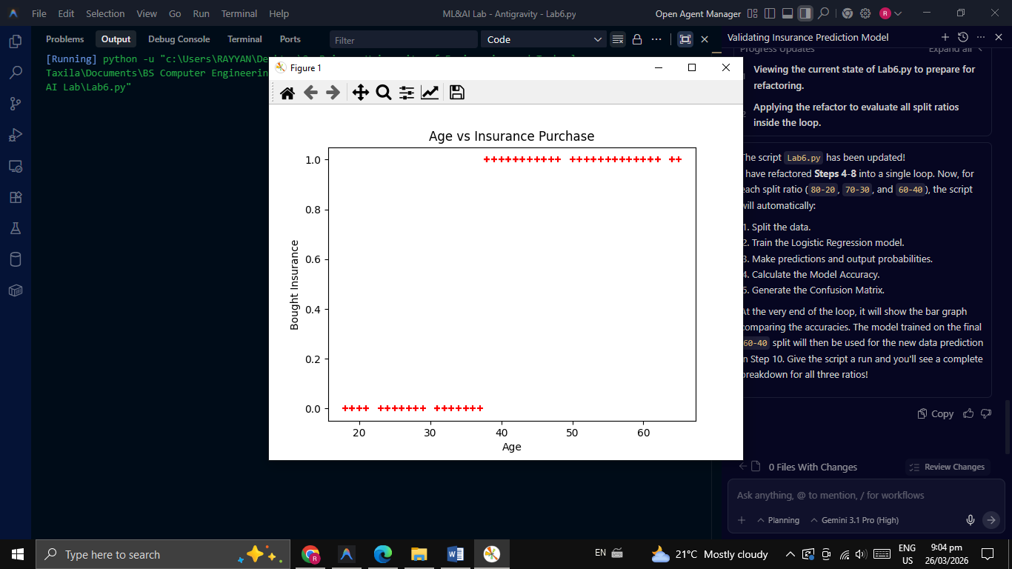
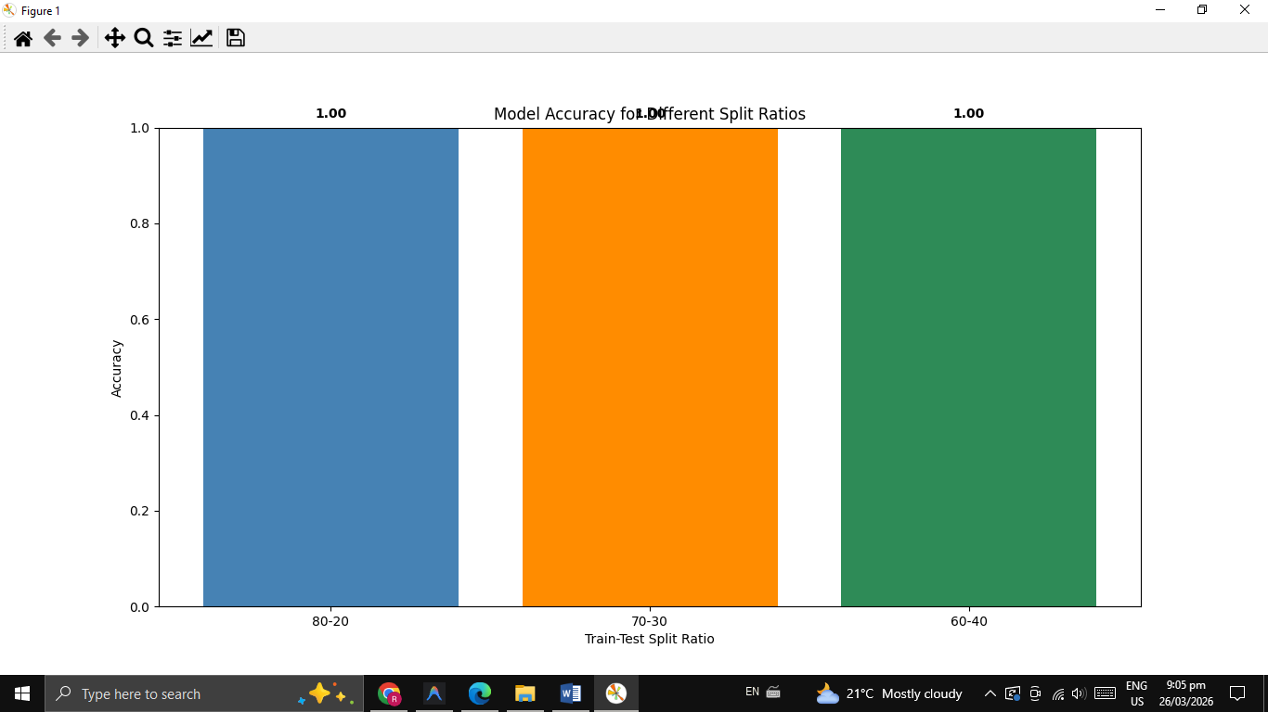
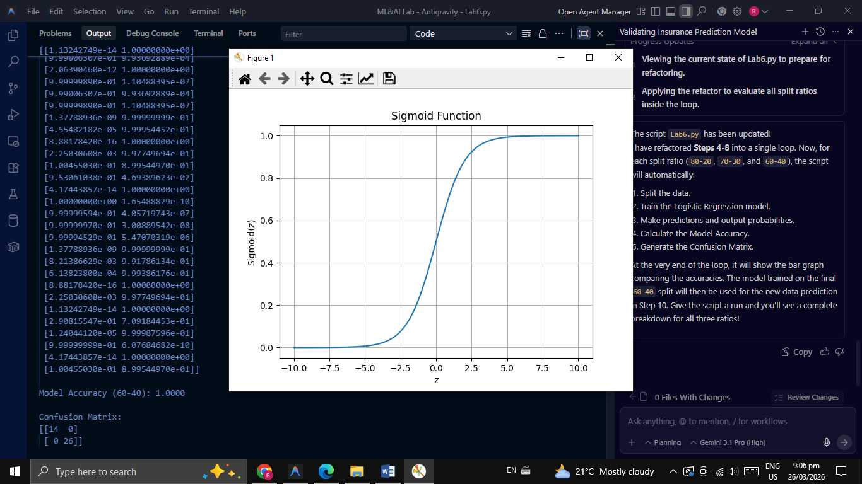
THE END

